The Collect for Remembrance Sunday

ACT OF COMMITMENT.
Minister Let us pledge ourselves anew to the service of God and humanity.
that we may help, encourage, and comfort others, and support those working for the relief of the needy and for the peace and welfare of the nations.

All Lord God our Father,
we pledge ourselves
to serve you and all humanity,
in the cause of peace,
for the relief of want and suffering,
and for the praise of your name.
Guide us by your spirit;
Give us wisdom;
Give us courage;
Give us hope;
And keep us faithful
now and always. Amen.

The Blessing
Go forth into the world in peace. Be of good courage; hold fast to that
which is good; render to no one evil; strengthen the faint hearted; support the weak; help the afflicted; honour all people; love and serve the Lord, rejoicing in the power of the Holy Spirit. And the blessing of God Almighty, the Father, the Son, and the Holy Spirit, be with you, and remain with you always. Amen

All The National Anthem

Wivelsfield Parish

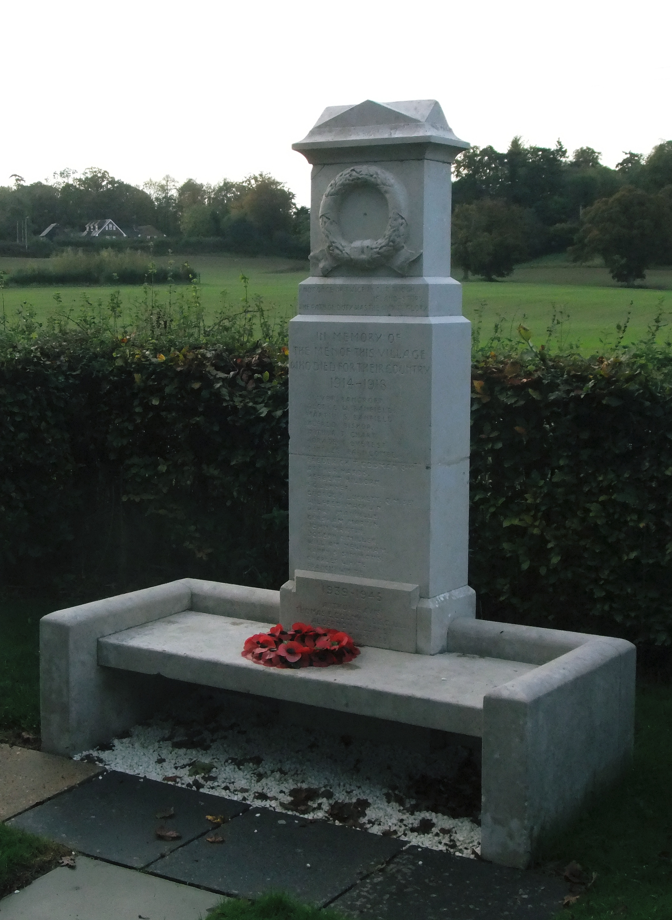

Remembrance Sunday

At the

Village War Memorial

INTRODUCTION
Minister We are here to worship Almighty God, whose purposes are good:
whose power sustains the world he has made: who loves us, though we have failed in his service; who gave Jesus Christ for the life of the world: who by his Holy Spirit leads us in his way.
As we give thanks for his great works, we remember those who have lived and died in his service and in the service of others; we pray for all who suffer through war and are in need: we ask for his help and blessing that we may do his will and that the whole world may acknowledge him as Lord and King.

Minster Let us confess to God the sins and shortcomings of the world; its pride, its selfishness, its greed; its evil divisions and hatreds
Let us confess our share in what is wrong, and our failure to seek and establish that peace which God wills for his children.

All Most merciful God,
we confess that we have sinned
in thought, word, and deed.
We have not loved you with our whole heart.
We have not loved our neighbours as ourselves.
In your mercy forgive what we have been,
help us to amend what we are,
and direct what we shall be;
that we may do justly, love mercy,
and walk humbly with you;
through Jesus Christ our Lord. Amen.

Minister Almighty God have mercy upon us, pardon and deliver us from all our sins, confirm and strengthen us in all goodness, and keep us in life eternal; through Jesus Christ our Lord. Amen

ACT OF REMEMBRANCE
Minister Let us remember with thankfulness before Almighty God, our heavenly Father, all who laid down their lives in the cause of freedom; recalling silently before him those whose names are upon our hearts, whose memory we treasure, and whose sacrifice is not forgotten.

The Roll of Honour
The Last Post

They shall grow not old as we that are left grow old:
Age shall not weary them, nor the years condemn.
At the going down of the sun and in the morning
We will remember them.
All We will remember them.

Here follows the SILENCE

Reveille

When you go home, Tell them of us and say,
For their tomorrow, We gave our today

Wreath Laying

Minister Almighty and eternal God, from whose love in Christ we cannot be parted, either by death or life: Hear our prayers and thanksgivings for those whom we remember this day; fulfil in them the purpose of your love; and bring us, with them, to your eternal joy; through Jesus Christ our Lord. Amen.

Reading Matthew 5:1-10 The Beatitudes

The Lord’s Prayer

All Our Father, who art in heaven,
hallowed be thy Name;
thy kingdom come;
thy will be done;
on earth as it is in heaven.
Give us this day our daily bread.
And forgive us our trespasses,
as we forgive those who trespass against us
and lead us not into temptation;
but deliver us from evil.
for thine is the kingdom,
the power, and the glory,
for ever and ever. Amen.

